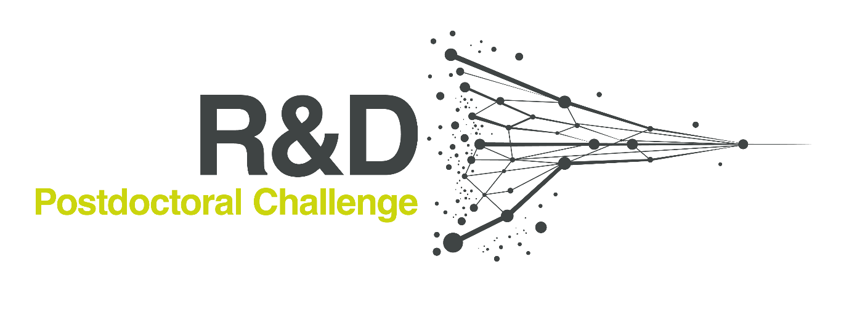

AstraZeneca R&D Postdoctoral Challenge Final – 19th October 2022
Finalist Overviews

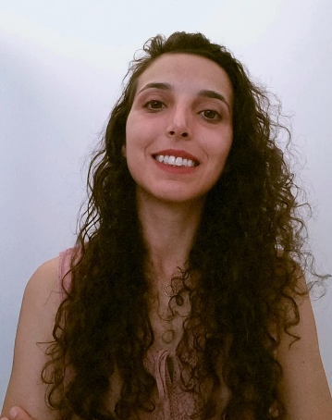
Dr. Ana Filipa Dias Louro
Postdoctoral Researcher at the Instituto de Biologia Experimental e Tecnológica (iBET), Portugal
Dr. Ana Filipa Dias Louro is a Postdoctoral Researcher at the Instituto de Biologia Experimental e Tecnológica (iBET) in Portugal. Filipa holds a PhD in Bioengineering (2022) from ITQB-NOVA, Portugal, and an Integrated Masters in Pharmaceutical Sciences (2014) from the University of Lisbon, Portugal. She completed her Master of Science project at the Faculty of Pharmacy of the University of Ljubljana, Slovenia, and was subsequently employed as an R&D scientist by a start-up company and later by a Portuguese pharma company.
Having won a PhD grant from the MIT Portugal program (2018), Filipa joined iBET and ITQB-NOVA to start a project entitled “Cell-based and cell-free strategies for cardiac repair”. Since then, Filipa has worked on developing cardiac microtissues from hiPSC-cardiomyocytes, and on investigating cell platforms to produce therapeutic extracellular vesicles. Filipa is currently working on the development of a biological ventricular assist device to provide functional support to failing hearts as part of the BRAV3 European project.
Filipa is passionate about research and excited to explore new ideas while embracing disruptive and ambitious projects. With her experience across several scientific areas, she aims to bridge the gap in regenerative medicine and its translation to clinic.
Proposal summary
Advancing extracellular vesicle-based therapies for cardiac regeneration
In her project, Filipa, aims to advance acellular, extracellular vesicle (EV)-based strategies for cardiac repair.
Intending to leverage previous data obtained during her Ph.D., in which the team discovered a specific miRNA signature in human induced pluripotent stem cell (hiPSC)-derived EV, targeting the PTEN/PI3K/AKT pathway. Indeed, hiPSC-EV were able to induce pro-angiogenic and pro-proliferative effects in vitro. Here, we aim to further explore the hypothesis that (native or hybrid) hiPSC-EV can promote cardiac tissue regeneration.

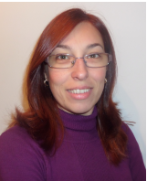
Cátia Alexandra Marques Bonito Ferreira
PhD Student at the Department of Chemistry and Biochemistry, University of Porto, Portugal
Cátia Alexandra Marques Bonito Ferreira is a PhD Student at the Department of Chemistry and Biochemistry, University of Porto in Portugal. Cátia currently lives with her family in Sweden and is awaiting her PhD defence. Cátia holds a Master of Science in Pharmaceutical Sciences (2007) and worked for five years in a pharmacy, where she provided healthcare services to the general population.

During those years, she realised that discovering novel therapeutic approaches to benefit people was a passion of hers and undertook a specialization Master Course in Biopharmaceutical Sciences (2013). By using in silico and in vitro approaches, she studied the molecular mechanisms underlying variant forms of medium-Chain acyl-CoA dehydrogenase, a flavoprotein involved in a rare metabolic disorder. As a BI fellow and, currently a PhD student in theoretical chemistry, she studied the potential allosteric binding sites in P-glycoprotein and searched for new scaffolds using novel approaches to tackle multidrug resistance (MDR) in cancer.

Although Cátia has been working in MDR in cancer, her passion is the study of rare metabolic disorders with no available pharmacological treatment. As a pharmacist, she had contact with many patients with several diseases, and wants to help improve their quality of life.

Proposal summary
Designing “first-in-class” pharmacological chaperones for rare metabolic disorders
Fatty acid oxidation disorders (FAODs) are inborn errors of metabolism resulting from an enzyme defect involved in the mitochondrial fatty acid β-oxidation pathway. Although individually rare, FAODs’ collective incidence is estimated to be one in 5,000-10,000 births. Among them, Medium-chain acyl-CoA dehydrogenase deficiency (MCADD) is the most common FAOD, with a mortality rate of at least 20% before the early diagnosis through New Born Screening. MCADD has an estimated worldwide prevalence of one in 15,000 births, being more prevalent in Northern European countries and in the United States of America. This is an autosomal recessive genetic disorder being the p.K329E the most common variant, and it is often associated with the most severe phenotype including hypoketotic hypoglycemia, seizures, coma and sudden death. Cátia’s proposal therefore aims to identify the “first-in-class” pharmacological chaperone, able to act as an enzyme stabiliser, by using a combination of computational and experimental approaches.

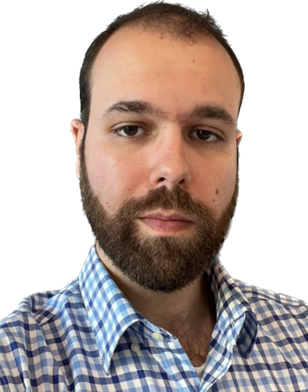
Dr. Gonçalo Emanuel Duarte Rosas da Silva
Project Scientist at Aramune Technologies Ltd., Northern Ireland
Dr. Gonçalo Emanuel Duarte Rosas da Silva is a Project Scientist at Aramune Technologies Ltd. in Northern Ireland. Originally from Porto, Portugal, Gonçalo completed his undergraduate and Master of Science studies in Biomedical Sciences at the University of Beira Interior. His final project focused on cancer metabolism, piquing his interest into how diseases and lifestyle habits are reflected as metabolic perturbations. He decided to focus solely on metabolism and moved to Queen’s University Belfast to undertake a Marie Curie-funded PhD in Metabolomics (2018).

Encouraged by his PhD program’s promotion of interdisciplinary research, Gonçalo became involved with several initiatives focused on scientific reproducibility, improving wet-dry lab communication across the biotechnology ecosystem as well as mental health. These experiences broadened his scientific interests to include the wider use of omics technologies to better understand health and disease. The use of this knowledge enables the development of novel therapeutics for the benefit of patients’ lives.

During the COVID-19 pandemic, Gonçalo took part in ICURe, an Innovate UK-backed customer discovery programme, as an entrepreneurial lead. His successful final pitch at the end of this programme aided the spin-out of Aramune Technologies, where he currently works.

Proposal summary
Characterisation of the cardiomyocyte surface proteome for the development of targeted therapies for heart failure
Cardiovascular diseases are the World's leading cause of death. Heart failure (HF) alone affects 65 million people globally, and its high mortality (roughly 50% within 5 years) and morbidity make it a major public health burden. Despite this, therapeutic options are sub-optimal, and existing treatments have undesirable off-target effects. Gonçalo proposes to map out the cell surface proteome of cardiomyocytes at different stages of HF, and identify key cell surface components associated with disease progression for the development of targeted therapies. He aims to empower safer medicines, and benefit novel protein-targeting therapeutic and carrier modalities in the future.

Dr. Mark Waterhouse
Postdoctoral Research Associate at the Department of Pharmacology, University of Cambridge, United Kingdom
Dr. Mark Waterhouse is a Postdoctoral Research Associate at the Department of Pharmacology, University of Cambridge in the United Kingdom. Originally from Brentwood, Mark’s science career started in secondary school, when one of his best friends sadly died from type 1 diabetes at age 17. This ignited his keen interest in autoimmunity, to understand how the body could harm itself and how this could be prevented in the future. This event was a key driving factor for Mark to study a Bachelor of Science in Biochemistry at the University of Essex. Here, Mark enjoyed immunology, drug design and discovery, and broadened his interest from type 1 diabetes to autoimmune disease in general.

Mark undertook a PhD at the University of Leeds where he worked on targeting Fc gamma receptors (FcγRs), which are immune cell-surface receptors for immunoglobulin G (IgG), for the treatment of complex autoimmune conditions like rheumatoid arthritis and lupus. He was fascinated with how FcγRs were integral to many different aspects of biology and from here found his niche in protein science and biophysics. FcyRs influence these processes through a complex multi-layered system that provides biological fine tuning of immune responses.
Mark has continued his protein work at the University of Cambridge by working on drugging several protein-protein interactions that are involved in aggressive epithelial tumours, such as triple-negative breast cancer and lung squamous carcinoma. As funding comes to an end, he is looking to combine his skills and passions, and return to the FcγR field. He aims to develop new therapies for autoimmune disease through degradation-based modulation of FcγRs. Through this project, he hopes to increase understanding of autoimmune disease and make a real difference to the lives of patients.
Proposal summary
Generating an Fcγ Receptor (FcγR) degrader toolbox to target FcγRs in autoimmune disease
Fcγ Receptors (FcγRs) are a family of cell-surface receptors for IgG that contribute to the protective functions of the immune system. However, aberrant activation of FcγRs by self-reactive IgG autoantibodies can lead to harmful inflammation, severe tissue damage and the development of chronic autoimmune disease. Mark’s proposal aims to generate an FcgR degrader toolbox ​to facilitate specific degradation of individual receptors. These molecules will be used to investigate receptor degradation as an alternative to the conventional inhibition of specific FcγR-IgG interactions, with the goal of this project to generate a panel of validated FcγR-modulating agents.

Dr. Rakhee K. Ramakrishnan
Postdoctoral Research Associate at the Research Institute for Medical and Health Sciences, University of Sharjah, United Arab Emirates

Dr. Rakhee K. Ramakrishnan is a Postdoctoral Research Associate with the Tissue Injury and Repair Research group, led by Professor Qutayba Hamid, at the Research Institute of Medical and Health Sciences, University of Sharjah in United Arab Emirates (UAE). She holds a Bachelor of Biotechnology and Biochemical Engineering from the University of Kerala in India. Attaining the School of Chemistry and Molecular Biosciences Indian Scholarship, Rakhee pursued her Master of Biotechnology (Advanced) from the University of Queensland in Australia.
During her Masters, Rakhee was awarded the John Kapeleris Medal for Biotechnology (2014) for exemplary academic performance. She completed her PhD in Molecular Medicine and Translational Research at the University of Sharjah in UAE, with a dual PhD degree from the University of Lübeck in Germany (2020). Rakhee has more than 25 publications in peer-reviewed scientific journals and has presented research posters at multiple national and international conferences.
Rakhee is passionate about research in the broad themes of mitochondrial metabolism and airway dysbiosis. Her research focus lies in understanding how mitochondrial metabolism, together with autophagy, regulates stress responses, metabolic functions, and immunity in homeostatic functions, as well as in pathological settings. Rakhee has worked in respiratory research for the past six years and developed an appreciation for the power of multi-OMICS as a research tool. She is intrigued by the adaption of a multi-OMICS approach to study the airway microbiome in respiratory diseases.
Proposal summary
Microbiome-based therapeutics for asthma
Asthma is a highly prevalent chronic inflammatory condition of the airways with complexity in its etiology, pathogenesis and heterogeneous disease presentation. Airway microbiome is increasingly appreciated to be an important contributor to lung health. Every study to date has shown a clear aberration in microbial composition and diversity in asthmatic airways from the healthy state. While airway dysbiosis affects multiple facets of asthma, the molecular basis of this regulation needs further elucidation. Furthermore, the metabolites produced by the various microbial communities are known to have broad systemic metabolic ramifications. Since microbiota interacts with the host by regulating mitochondrial function, mitochondrial dysfunction imposed by dysbiosis can pave way to diseased states. However, the metabolic interaction between the airway microbiome and host in asthma is poorly characterised. Rakhee’s proposal presents a multi-omics approach to analyse the airway microbiome and associated metabolome in asthma. She speculates that airway dysbiosis in asthma predisposes airway cells to mitochondrial dysfunction through a dysregulation in the microbial metabolites.

Patience Chihomvu
Postdoctoral Fellow, University of the Witwatersrand Medical School, South Africa
Dr. Patience Chihomvu obtained her BSc (Hons) at the National University of Science and Technology in Bulawayo, Zimbabwe. She began working as a Food Science and Nutrition Lecturer following her graduation and supervised Higher National Diploma students on their final year projects. Patience applied for her master’s degree in research at the Vaal University of Technology in 2013 and obtained extensive research experience in Prof. M. Pillay's Molecular lab. During this time she isolated heavy metal-resistant bacteria from the Klip River and successfully isolated the plasmids and genes responsible for heavy metal resistance. Following the isolation of heavy metal resistance genes, bioinformatics analysis was used to determine the structure and functionality of the genes in silico. This encouraged Patience’s research interests in the application of computer modelling and bioinformatics.
Under the supervision of Prof. M. Pillay, Dr C. C. Ssemakalu, and Dr E. Ubomba-Jaswa, Patience worked on her PhD thesis: 'Effects of solar irradiation S. Typhimurium and C. jejuni on the proliferation and activation of RAW264.7 macrophages in Vitro. Patience has been recognised with multiple awards for her research, including the Vaal University of Technology Masters Research Award, the Vaal University of Technology Doctorate Research Award and the S & F Innovation Doctoral Awards - National Research Foundation. Patience continues to focus her research on microbiology, molecular biology, and tissue culture and currently lectures at the Vaal University of Technology in South Africa.
Proposal summary
Characterisation of anti-inflammatory properties of Lippia javanica
Lippia javanica is ubiquitous in Southern Africa (Asiata, 2016). The ethnomedical uses of L. javanica include treating chest pains, bronchitis, asthma, wounds, fevers, and malaria. Alkaloids, amino acids, flavonoids, iridoids, triterpenes, and other volatile and nonvolatile secondary metabolites are just a few phytochemicals in L. javanica. It also contains several minerals. The plant possesses a wide range of pharmacological activities, including anticancer, antiamoebic, antidiabetic, antimalarial, antimicrobial, antioxidant, antiplasmodial, and pesticidal effects, which have been linked to L. javanica in scientific studies. Many of the traditional uses of L. javanica have been confirmed by phytochemical and pharmaceutical studies, but there are still some knowledge gaps that could be filled (Maroyi, 2017). Although Lippia javanica is being used extensively in phytomedicine, more thorough research is required to evaluate and isolate bioactive compounds to assess the efficacy, safety, and therapeutic importance of its critical active components. Therefore, Patience’s project aims to characterise L. javanica’s phytochemical profile and anti-inflammatory properties.

